Unit #: 1
Unit Name: Problem solving Fundamentals
Topic: Single Character input and output – Problem solving

Course objectives:
The objective(s) of this course is to make students
CObj1: Acquire knowledge on how to solve relevant and logical problems using computing machine
CObj2: Map algorithmic solutions to relevant features of C programming language constructs
CObj3: Gain knowledge about C constructs and it's associated eco-system
CObj4: Appreciate and gain knowledge about the issues with C Standards and it's respective behaviors
CObj5: Get insights about testing and debugging C Programs

Course outcomes:
At the end of the course, the student will be able to
CO1: Understand and apply algorithmic solutions to counting problems using appropriate C Constructs
CO2: Understand, analyse and apply text processing and string manipulation methods using C Arrays, Pointers and functions
CO3: Understand prioritized scheduling and implement the same using C structures
CO4: Understand and apply sorting techniques using advanced C contructs
CO5: Understand and evaluate portable programming techniques using preprocessor directives and conditional compilation of C Programs

Counting Problem
We are required to find the number of characters, number of words and number of lines in an user input and in a given file. We want to simulate a program in Unix command called wc – word count .

We have not learnt yet how to play with files in our programs. It is a bit too early in this course. We do know how to read from the keyboard. Can the operating system open a file for me and make it logically available on the keyboard? It can. This concept is called input redirection.

input redirection:
$ executable < filename
It is similarly possible to collect the output of the program which would appear on the screen in a file using output redirection.

output redirection:
$ executable > filename

To solve this problem stated, we should know
- how to read and display a character?-Discussed in Character I/O
- how to read a line?–Discussed in Character I/O
- how to make out when we reach the end of file?
- how to break a given sequence of characters into words and lines?

Few points to think before we start with the solution.
- It is always preferred to read at only one place.
- If you read input at two places, code could work. But what if we reach EOF in the inner loop?
- It It is always preferred to have a while with an if over while within a while.
- Can we use a boolean variable to indicate whether we are in a word or not.
- If we are in a word and we reach a space, the word ends and we count. If we are not in a word and we encounter a space, we ignore it. We set in_word when we encounter a non-white-space.

Coding Example_1: Reading a character and displaying a character
#include<stdio.h>
int main()
{ char ch = getchar();
putchar(ch);
return 0;
}

Coding Example_2: Reading a line and displaying a line
#include<stdio.h>
int main()
{ char ch;
while((ch = getchar()) != '\n')
{
putchar(ch);
}
return 0;
}
Our hurdle is to read the whole file. How do we know we have reached the end of file. ‘C’ handles this in a very interesting way. When the end of file is reached –which the operating system can make out –a particular value gets is returned by getchar. This value is decided by ‘C’ and not by the operating system. This value is associated with the name EOF. So, we keep reading until getchar returns EOF.

Coding Example_3: Reading characters till EOF and displaying it
#include<stdio.h>
int main()
{
// printf("%d",EOF); // EOF is a macro which has the value -1 in stdio.h
char ch;
while((ch = getchar()) != EOF')
{
putchar(ch);
}
return 0;
}

Coding Example_4: Solution to find the number of characters, number of words and number of lines in an user input and in a given file
Every character read is considered for character count. Word count is incremented if it encounters a space or a tab(\t) or new line(\n). Line count is incremented when it encounters a new line(\n)
#include<stdio.h>
int main()
{
char ch;
int nl = 0;
int nw = 0;
int nc = 0;
while((ch = getchar()) != EOF)
{
nc++;
if(ch == '\n')
nl++;

if(ch == ' ' || ch == '\t' || ch == '\n')
{
nw++;
}
}
printf("words = %d\nlines = %d\ncharacters=%d\n",nw,nl,nc);
return 0;
}
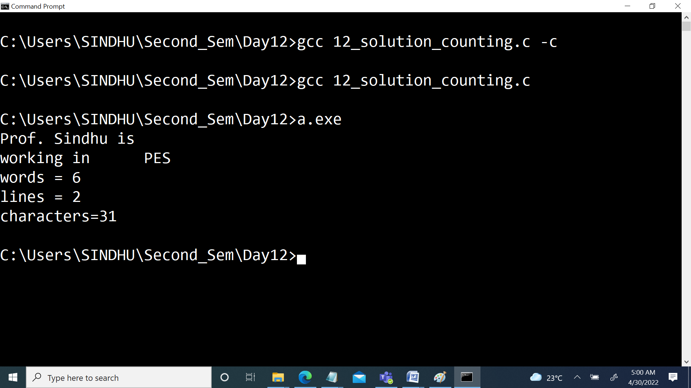

If the data file contains the same content, how do we give this data file as an input to this executable? Using redirection operator (<) as below.
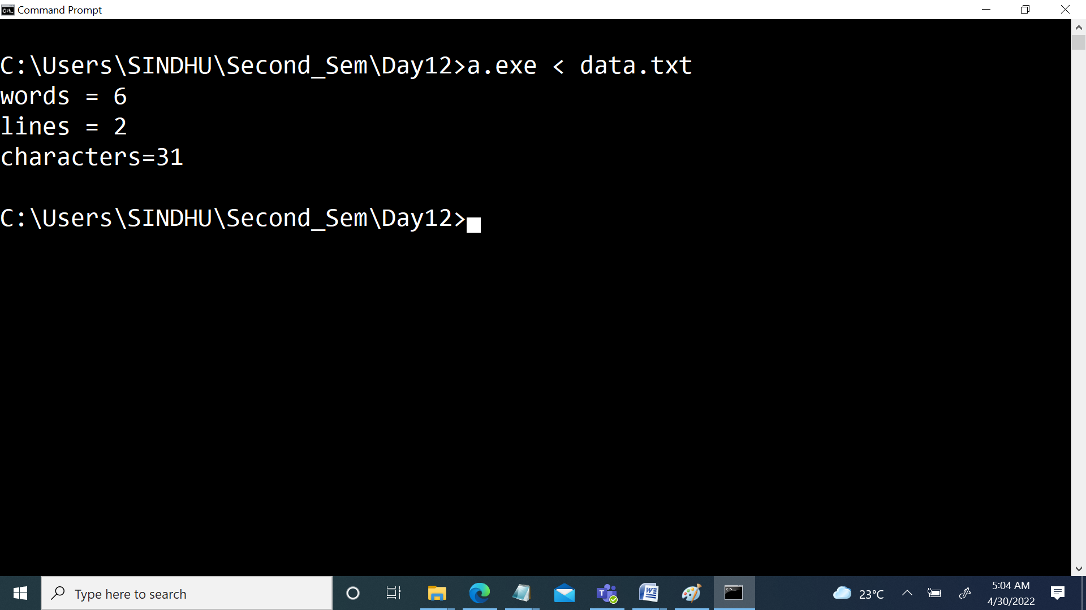

The problem with the above is if the data contains multiple spaces and multiple new lines, the respective counts will be incremented.
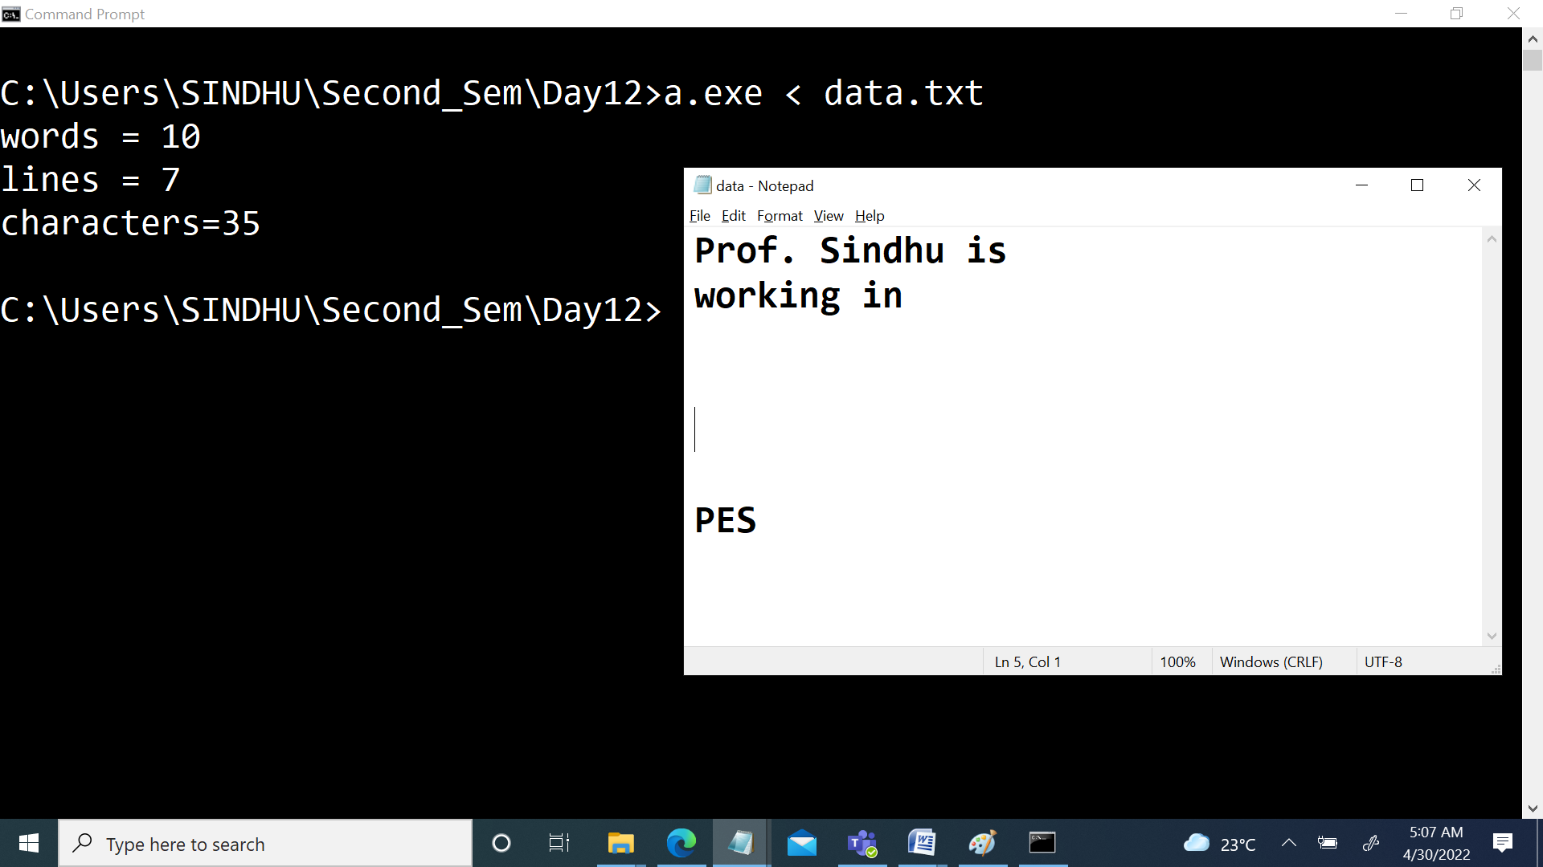

Coding Example_5: The above issue can be avoided by using a boolean variable to indicate whether we are in a word or not. If we are in a word and we reach a space, the word ends and we count. If we are not in a word and we encounter a space, we ignore it. We set inword when we encounter a non-white-space.
#include<stdio.h>
int main()
{
int inword = 0;
while((ch = getchar()) != EOF)
{
//putchar(ch);
nc++;
if(ch == '\n')
nl++;
if(inword && (ch == ' ' || ch == '\n' || ch == '\t'))
{
nw++;
inword = 0;
}
else if(!(ch == ' ' || ch == '\n' || ch == '\t'))
{
inword = 1;
}
}
printf("words = %d\nlines = %d\ncharacters=%d\n",nw,nl,nc);
return 0;
}

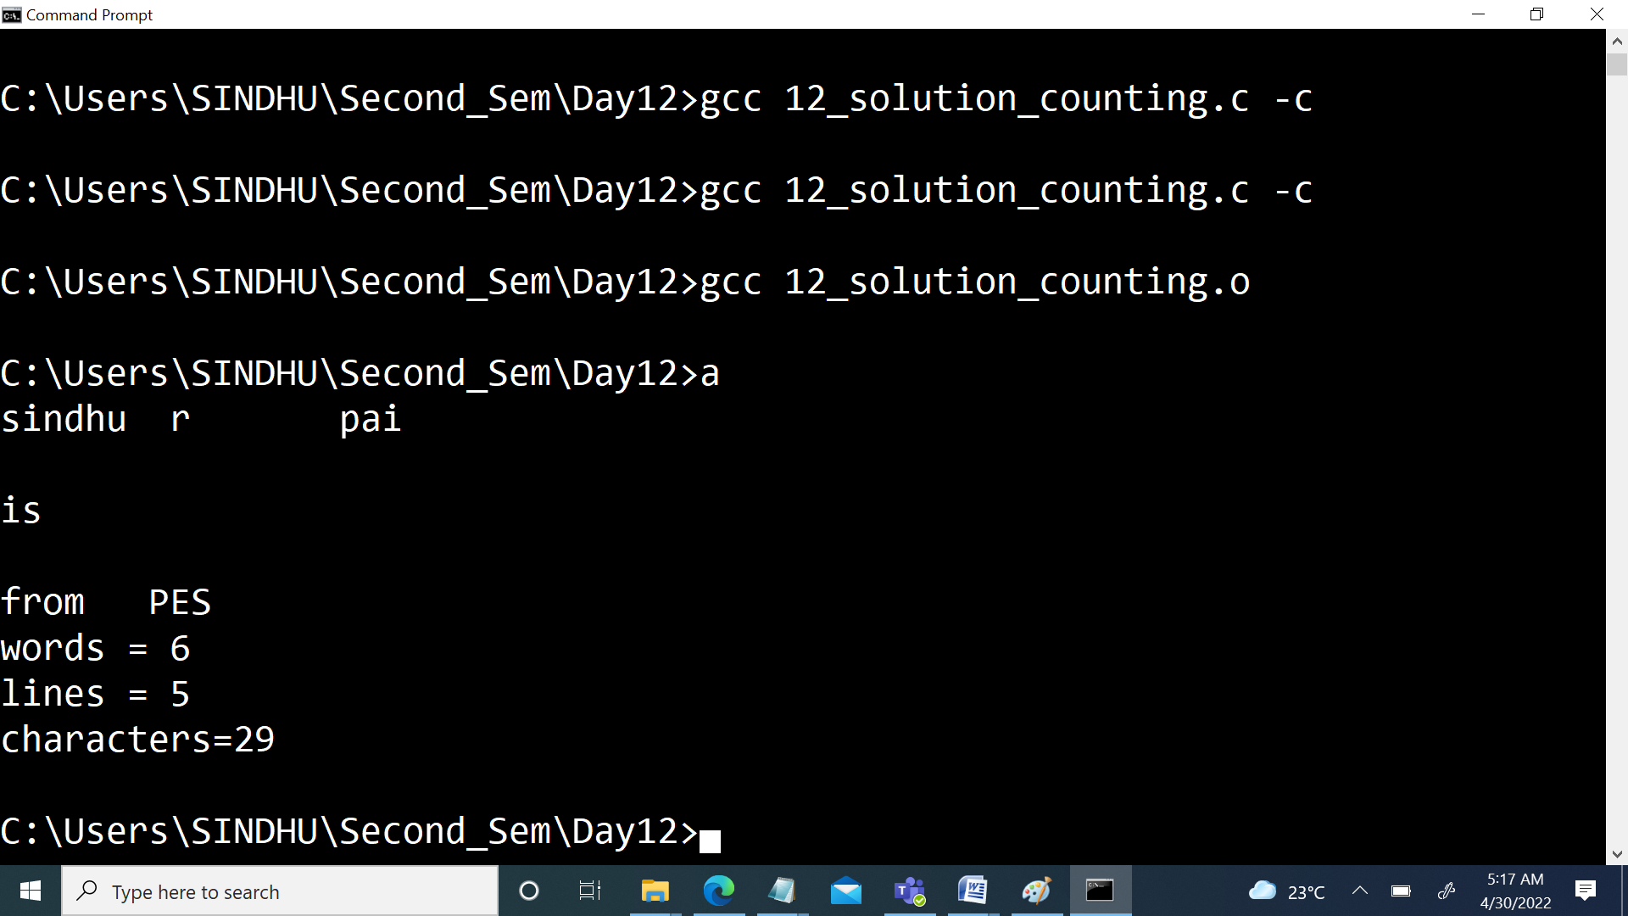

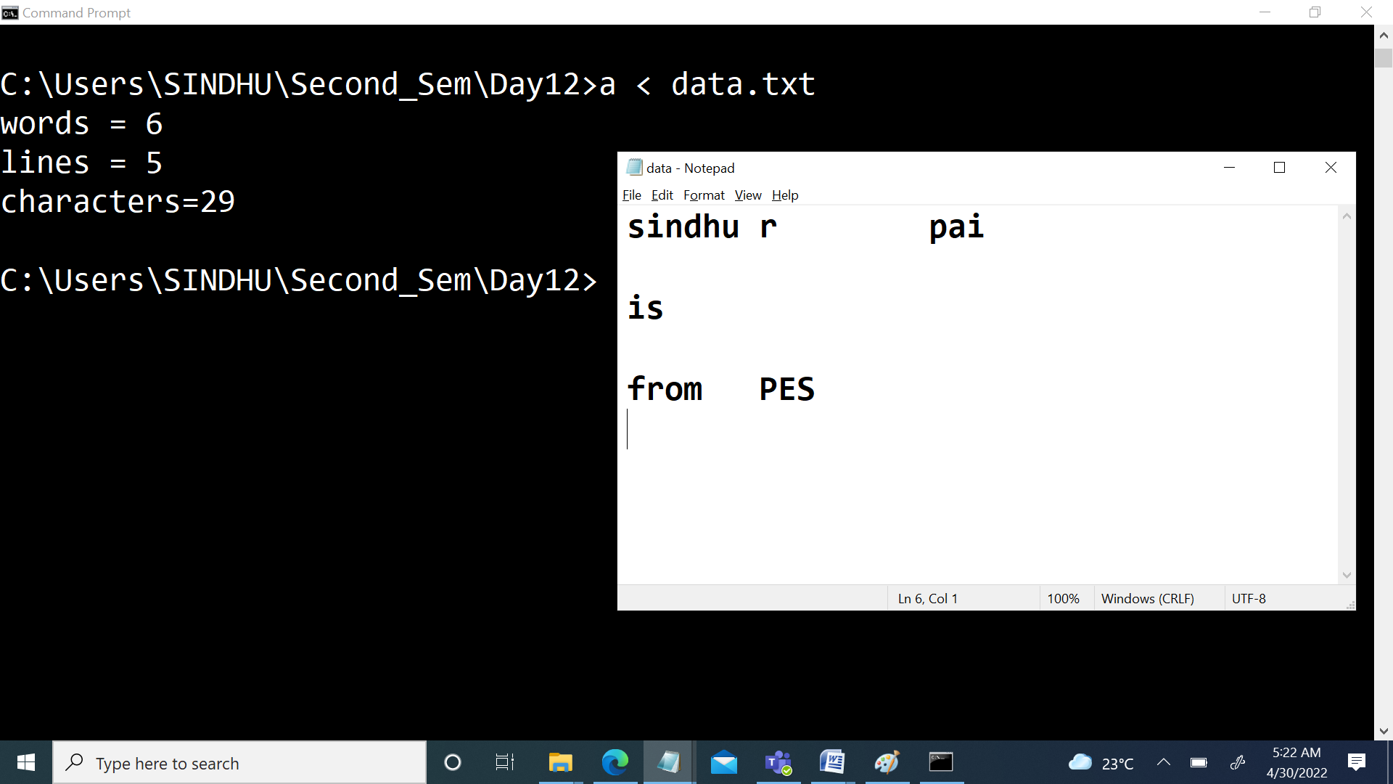

The above code solves the issue of word count with respect to multiple spaces and multiple lines. Include the logic for handling the line count when there is no data/content in the line with multiple new line characters.

This completes Unit – 1..!

